Main Screen

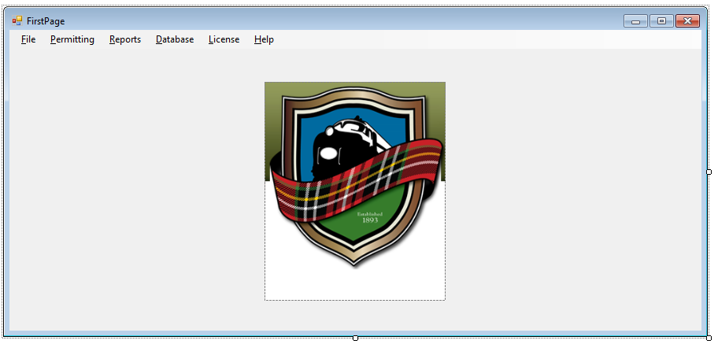

Every Part of the program will be accessible from the menus on this page. An optional group of links can easily be added to the left and/or right of the image if you would like commonly used links.

Building Permit Form

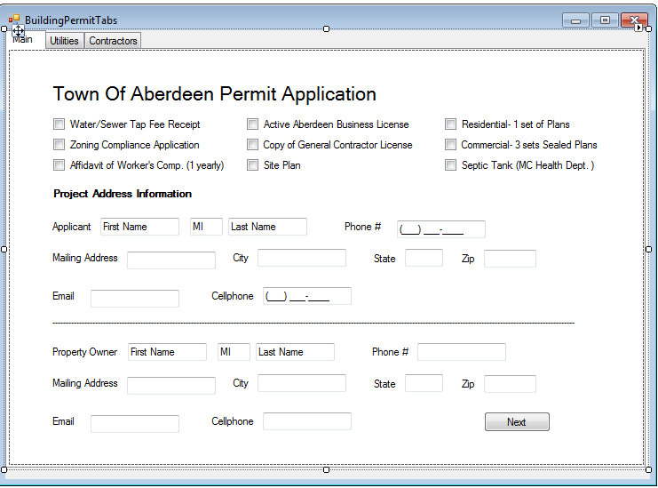

Layout of forms for data entry and retrieval are based on paper forms for easy data entry, and readability.

Part 2

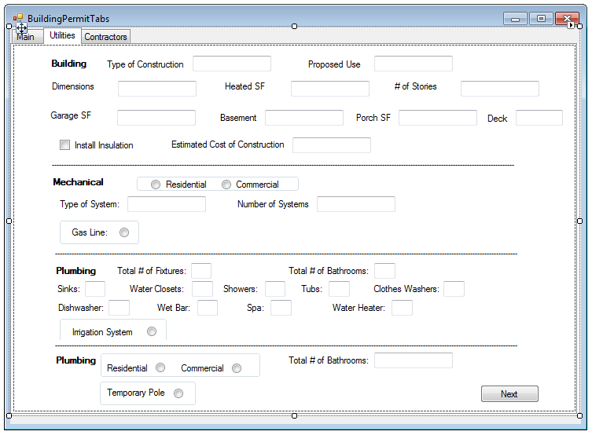

Tabs had to be used because there were too many entries for the screen to display, but next button was also added so as you tab fields the final tab on each page will go to the next button for data entry without ever having to use the mouse.

Part 3

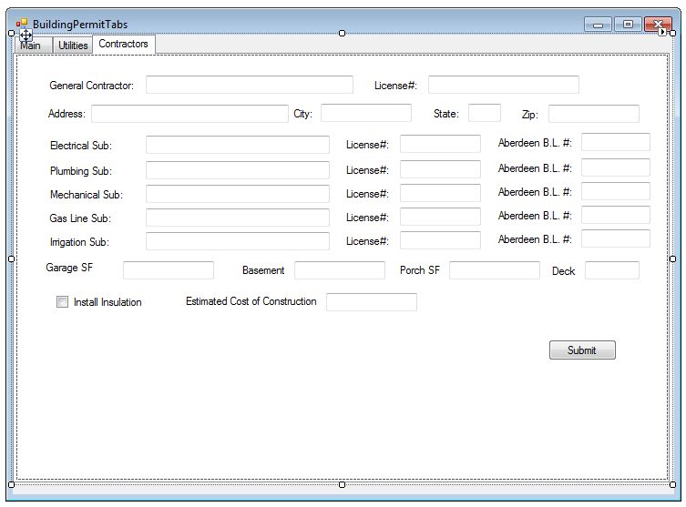

Final page has submit button, and a clear button can be added. Currently if you wanted to go back you would have to use the mouse, but other buttons can be added for navigation if wanted.

Search Box Example

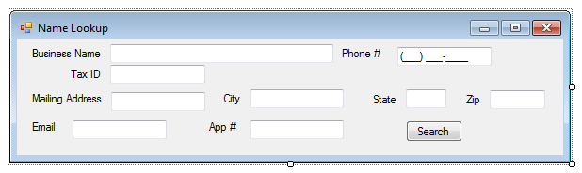

Search Boxes will be available on most all of the forms that will pop up as to keep the accessed form open. Any of the data fields can be used to search for information. Order of fields can be changed but ideally they will be the same arrangement on the search forms, and on any other forms for consistency.